INDUSTRIAL TRAINING REPORT

Course-AIML(6weeks)

(Industrial Training)

National Institute of Electronics & Information Technology ( NIELIT ), Ropar



Submitted By : Komal Yadav

Archna

Rajni

Submission Date:



GURU NANAK DEV UNIVERSITY, AMRITSAR

University Institute of Technology

Department of Electronics Technology

TABLE OF CONTENTS

ACKNOWLEDGEMENT………………………………………………………………………

Certificate…………………………………………………………………………………….....

Web Development………………………………………………………………………………

HTML…………………………………………………………………………………………

CSS……………………………………………………………………………………………

Python……………………………………………………………………………………….......

Numpy…………………………………………………………………………………………..

Pandas…………………………………………………………………………………………..

Machine Learning……………………………………………………………………………….

About Project …………………………………………………………………………………...

ACKNOWLEDGEMENT

It is a pleasure to acknowledge many people who knowingly and unwillingly helped me, to complete my project. First of all, let us praise GOD for all the blessings, which carried us through all these years.

We extend our most gratitude to **Dr. Sarwan Singh** who always stood by our side and guided, appreciated and encouraged us to get into more and more venture. Continuing the same, they enlightened us in the various stages during the development of this project and provided me with many insights and useful examples, which proved to be immense help in the successful completion of the project.

We extend our sincere gratitude to our all teachers and guides who made unforgettable contribution. Due to their sincere efforts, we are able to work for such an organization and excel in the work entrusted upon us.

We value the friendly encouragement that we have got from all our classmates.there is still a debt we owe to our parents, friends, all the well-wishers who were directly and indirectly involved in making this project a reality.

COMPLETION CERTIFICATE

# HTML

The **Hypertext Markup Language** or **HTML** is the standard markup language for documents designed to be displayed in a web browser.

**Hyper text:** Hypertext refers to links that connect web pages to one another, either within a single website or between websites. Links are a fundamental aspect of the Web. By uploading content to the Internet and linking it to pages created by other people, you become an active participant in the World Wide Web.

**Markup Language:** A markup language is a text-encoding system consisting of a set of symbols inserted in a text document to control its structure, formatting, or the relationship between its parts. Markup is often used to control the display of the document or to enrich its content to facilitate automated processing.

# Feature of HTML

1. It is a very easy and simple language. It can be easily understood and modified.
2. It is very easy to make an effective presentation with HTML because it has a lot of formatting tags.
3. It is a markup Language, so it provides a flexible way to design web pages along with text.
4. HTML is a case-insensitive language, which means we can use tags either in lower or upper case.
5. It is a platform-independent because it can displayed on any platform like Windows, Linux, Macintosh and Many more.

# CSS

Cascading Style Sheets, fondly referred to as CSS, is a simply designed language intended to simplify the process of making web pages presentable. CSS allows you to apply styles to web pages. More importantly, CSS enables you to do this independent of the HTML that makes up each web page. It describes how a webpage should look:

it prescribes colors, fonts, spacing, and much more. In short, you can make your website look however you want. CSS lets developers and designers define how it behaves, including how elements are positioned in the browser. While html uses tags, css uses rule sets. CSS is easy to learn and understand, but it provides powerful control over the presentation of an HTML document.

## Three Ways to Insert CSS

There are three ways of inserting a style sheet:

**i) External style sheet (Using HTML <link> Tag):** External CSS contains separate CSS file which contains only style property with the help of tag attributes (For example class, id, heading, … etc). CSS property written in a separate file with css extension and should be linked to the HTML document using link tag. This means that for each element, style can be set only once and that will be applied across web pages. The link tag is used to link the external style sheet with the html webpage.

**<link rel="stylesheet" href="style.css">**

**ii) Internal style sheet (Using the <style> Element):** This can be used when a single HTML document must be styled uniquely. The CSS rule set should be within the HTML file in the head section i.e the CSS is embedded within the HTML file.

**<style>**

**element{**

**// CSS property;**

**}**

**</style>**

**iii) Inline Style:** Inline CSS contains the CSS property in the body section attached with element is known as inline CSS. This kind of style is specified within an HTML tag using style attribute. It is used to apply a unique style for a single element.

**<h1 style="style property">Artificial Intelligence</h1>**

## Features of CSS

1) Maintenance: It is easy to maintain, changing in a single place will affect globally in your web site. No need to change every specific place.

2) Time-saving: You can easily use any single CSS script at multiple places.

3) Support: CSS is supported by all the browsers and search engines.

4) Cache storing: CSS can store web applications locally with the help of offline cache so you can see the web site when you are offline

# PYTHON

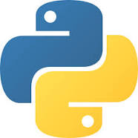Python is a general purpose, dynamic, high-level, and interpreted programming language. It supports Object Oriented programming approach to develop applications. It is simple and easy to learn and provides lots of high-level data structures. Python is easy to learn yet powerful and versatile scripting language, which makes it attractive for Application Development. Python's syntax and dynamic typing with its interpreted nature make it an ideal language for scripting and rapid application development. Python supports multiple programming patterns, including object-oriented, imperative, and functional or procedural programming styles. Python is not intended to work in a particular area, such as web programming. That is why it is known as multipurpose programming language because it can be used with web, enterprise, 3D CAD, etc. We don't need to use data types to declare variable because it is dynamically typed so we can write a=10 to assign an integer value in an integer variable.

## History

Python was invented by **Guido van Rossum** in 1991 at CWI in Netherland. The idea of Python programming language has taken from the ABC programming language or we can say that ABC is a predecessor of Python language. There is also a fact behind the choosing name Python. **Guido van Rossum** was a fan of the popular BBC comedy show of that time, "Monty Python's Flying Circus". So he decided to pick the name Python for his newly created programming language.

## Where is Python used?

Python is a general-purpose, popular programming language and it is used in almost every technical field. Some important applications of Python are summarized below:

**➢ Data Science:** Python experienced a recent emergence in popularity charts, mainly because of its Data science libraries. A huge amount of data is being generated today by web applications, mobile applications, and other devices. Companies need business insights from this data.

**➢ Machine Learning:** This is another key application area of Python. Python libraries such as Scikit-learn, Tensor flow and NLTK are widely used for the prediction of trends like customer satisfaction, projected values of stocks, etc. Some of the real-world applications of machine learning include medical diagnosis, statistical arbitrage, basket analysis, sales prediction, etc.

➢ **Web Development:** This is another application area in which Python is becoming popular. Web application framework libraries like django, Pyramid, Flask, etc. make it very easy to develop and deploy simple as well as complex web applications. These frameworks are used extensively by various IT companies. Drop box, for example, uses Django as a backend to store and synchronize local folders.

➢ **Image Processing:** The Open CV library is commonly used for face detection and gesture recognition. Open CV is a C++ library but has been ported to Python. Because of the rapid development of this feature, Python is a very popular choice from image processing.

➢ **Embedded Systems and IoT:** Another important area of Python application is in embedded systems. Raspberry Pi is a very popular yet low-cost single-board computer. It is extensively used in automation products, robotics, IoT, and kiosk applications.

## Python Popular Frameworks and Libraries

» Web development (Server-side) - Django Flask, Pyramid, CherryPy

» GUIs based applications - Tk, PyGTK, PyQt, PyJs, etc.

» Machine Learning - Tensor Flow, Scikit-learn, Matplotlib, Scipy, Seaborn

» Mathematics- Numpy, Pandas, etc.

# NUMPY

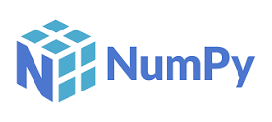NumPy is a Python package. It stands for 'Numerical Python'. It is a library consisting of multidimensional array objects and a collection of routines for processing of array.

**Travis Oliphant** created NumPy package in 2005 by injecting the features of the ancestor module Numeric into another module Numarray.

It is an extension module of Python which is mostly written in C. It provides various functions which are capable of performing the numeric computations with a high speed. NumPy provides various powerful data structures, implementing multi-dimensional arrays and matrices. These data structures are used for the optimal computations regarding arrays and matrices.

**Why is NumPy Faster Than Lists?**

» NumPy arrays are stored at one continuous place in memory unlike lists, so processes can access and manipulate them very efficiently.

» This behavior is called locality of reference in computer science.

» This is the main reason why NumPy is faster than lists. Also it is optimized to work with latest CPU architectures.

**Which Language is NumPy written in?**

NumPy is a Python library and is written partially in Python, but most of the parts that require fast computation are written in C or C++.

## Operations using NumPy

Using NumPy, a developer can perform the following operations −

• Mathematical and logical operations on arrays.

• Fourier transforms and routines for shape manipulation.

• Operations related to linear algebra. NumPy has in-built functions for linear algebra and random number generation.

## The need of NumPy

With the revolution of data science, data analysis libraries like NumPy, SciPy, Pandas, etc. have seen a lot of growth. With a much easier syntax than other programming languages, python is the first choice language for the data scientist. There are the following advantages of using NumPy for data analysis.

1. NumPy performs array-oriented computing.

2. It efficiently implements the multidimensional arrays.

3. It is capable of performing Fourier Transform and reshaping the data stored in multidimensional arrays.

4. NumPy provides the in-built functions for linear algebra and random number generation.

Nowadays, NumPy in combination with SciPy and Mat-plotlib is used as the replacement to MATLAB as Python is more complete and easier programming language than MATLAB.

**Jupyter notebook:**

[**http://localhost:8888/notebooks/3%20JUNE%20AIML.ipynb**](http://localhost:8888/notebooks/3%20JUNE%20AIML.ipynb)

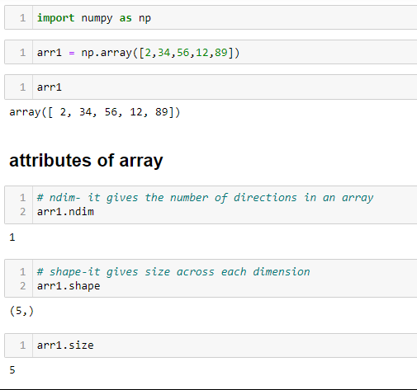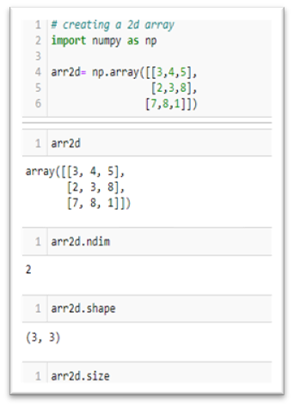

# PANDAS

Pandas is an open-source Python Library providing high-performance data manipulation and analysis tool using its powerful data structures. The name Pandas is derived from the word Panel Data – an Econometrics from Multidimensional data.In 2008, developer Wes McKinney started developing pandas when in need of high performance, flexible tool for analysis of data. Python pandas are one of the most widely-used Python libraries in data science and analytics. It provides high-performance, easy-to-use structures, and data analysis tools Data analysis requires lots of processing, such as restructuring, cleaning or merging, etc. There are different tools are available for fast data processing, such as Numpy, Scipy, Cython, and Panda. But we prefer Pandas because working with Pandas is fast, simple and more expressive than other tools. Pandas is built on top of the Numpy package, means Numpy is required for operating the Pandas.

## Features of Pandas:

* It has a fast and efficient Data Frame object with the default and customized indexing.
* Used for reshaping and pivoting of the data sets.
* Group by data for aggregations and transformations.
* It is used for data alignment and integration of the missing data.
* Process a variety of data sets in different formats like matrix data, tabular heterogeneous, time series.
* Handle multiple operations of the data sets such as sub setting, slicing, filtering, group By, re-ordering, and re-shaping.
* It integrates with the other libraries such as SciPy, and scikit-learn.
* Provides fast performance, and If you want to speed it, even more, you can use the Python.

## Benefits of Pandas

The benefits of pandas over using other language are as follows:

▪ Data Representation: It represents the data in a form that is suited for data analysis through its Data Frame and Series.

▪ Clear code: The clear API of the Pandas allows you to focus on the core part of the code. So, it provides clear and concise code for the user.

**Jupyter notebook:**

[**http://localhost:8888/notebooks/3%20JUNE%20AIML.ipynb**](http://localhost:8888/notebooks/3%20JUNE%20AIML.ipynb)

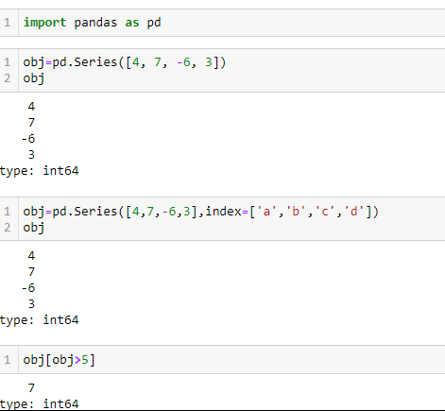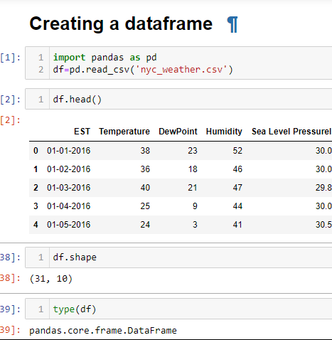

# Machine Learning

Machine learning is a growing technology which enables computers to learn automatically from past data. Machine learning uses various algorithms for building mathematical models and making predictions using historical data or information. Currently, it is being used for various tasks such as image recognition, speech recognition, email filtering, Facebook auto tagging, recommender system, and many more. This machine learning tutorial gives you an introduction to machine learning along with the wide range of machine learning techniques such as Supervised, Unsupervised, and Reinforcement learning. You will learn about regression and classification models, clustering methods, hidden Markov models, and various sequential models. Machine Learning is said as a subset of artificial intelligence that is mainly concerned with the development of algorithms which allow a computer to learn from the data and past experiences on their own. The term machine learning was first introduced by Arthur Samuel in 1959. We can define it in a summarized way as:

“ Machine learning enables a machine to automatically learn from data, improve performance from experiences, and predict things without being explicitly programmed. “

With the help of sample historical data, which is known as training data, machine learning algorithms build a mathematical model that helps in making predictions or decisions without being explicitly programmed. Machine learning brings computer science and statistics together for creating predictive models. Machine learning constructs or uses the algorithms that learn from historical data. The more we will provide the information, the higher will be the performance. A machine has the ability to learn if it can improve its performance by gaining more data.

## How does Machine Learning work?

A Machine Learning system learns from historical data, builds the prediction models, and whenever it receives new data, predicts the output for it. The accuracy of predicted output depends upon the amount of data, as the huge amount of data helps to build a better model which predicts the output more accurately.

The below diagram explains the Working of Machine Learning Algorithm:

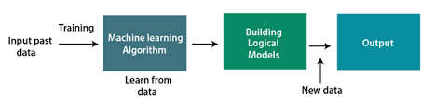

### Features of Machine Learning:

▪ Machine learning uses data to detect various patterns in a given dataset.

▪ It can learn from past data and improve automatically.

▪ It is a data-driven technology.

▪ Machine learning is much similar to data mining as it also deals with the huge amount of the data.

## Need for Machine Learning:

The need for machine learning is increasing day by day. The reason behind the need for machine learning is that it is capable of doing tasks that are too complex for a person to implement directly. As a human, we have some limitations as we cannot access the huge amount of data manually, so for this, we need some computer systems and here comes the machine learning to make things easy for us.

The importance of machine learning can be easily understood by its uses cases, Currently, machine learning is used in self-driving cars, cyber fraud detection, face recognition, and friend suggestion by Facebook, etc. Various top companies such as Netflix and Amazon have build machine learning models that are using a vast amount of data to analyze the user interest and recommend product accordingly.

➢ Following are some key points which show the importance of Machine Learning:

* Rapid increment in the production of data
* Solving complex problems, which are difficult for a human
* Decision making in various sector including finance
* Finding hidden patterns and extracting useful information from data.

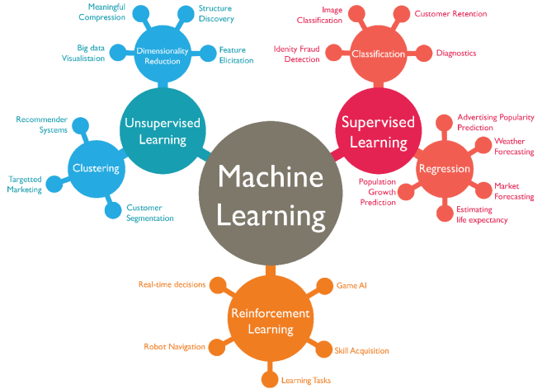

## Classification of Machine Learning:

At a broad level, machine learning can be classified into three types:

1. Supervised learning
2. Unsupervised learning
3. Reinforcement learning

## 1). Supervised Learning:

Supervised learning is a type of machine learning method in which we provide sample labeled data to the machine learning system in order to train it, and on that basis, it predicts the output.The system creates a model using labeled data to understand the datasets and learn about each data, once the training and processing are done then we test the model by providing a sample data to check whether it is predicting the exact output or not. The goal of supervised learning is to map input data with the output data. The supervised learning is based on supervision, and it is the same as when a student learns things in the supervision of the teacher. The example of supervised learning is spam filtering.

Supervised learning can be grouped further in two categories of algorithms:

* Classification
* Regression

## 2) Unsupervised Learning

Unsupervised learning is a learning method in which a machine learns without any supervision. The training is provided to the machine with the set of data that has not been labeled, classified, or categorized, and the algorithm needs to act on that data without any supervision. The goal of unsupervised learning is to restructure the input data into new features or a group of objects with similar patterns.In unsupervised learning, we don't have a predetermined result. The machine tries to find useful insights from the huge amount of data. It can be further classifieds into two categories of algorithms:

* Clustering
* Association

## 3) Reinforcement Learning

Reinforcement learning is a feedback-based learning method, in which a learning agent gets a reward for each right action and gets a penalty for each wrong action. The agent learns automatically with these feedbacks and improves its performance. In reinforcement learning, the agent interacts with the environment and explores it. The goal of an agent is to get the most reward points, and hence, it improves its performance.

The robotic dog, which automatically learns the movement of his arms, is an example of Reinforcement learning. We are using machine learning in our daily life even without knowing it such as Google Maps, Google assistant, Alexa, etc. Below are some most trending real-world

## Applications of Machine Learning:

1. Image Recognition: Image recognition is one of the most common applications of machine learning. It is used to identify objects, persons, places, digital images, etc. Facebook provides us a feature of auto friend tagging suggestion. Whenever we upload a photo with our Face book friends, then we automatically get a tagging suggestion with name, and the technology behind this is machine learning's face detection and recognition algorithm. It is based on the Face book project named "Deep Face," which is responsible for face recognition and person identification in the picture.
2. Speech Recognition: While using Google, we get an option of "Search by voice," it comes under speech recognition, and it's a popular application of machine learning. Speech recognition is a process of converting voice instructions into text, and it is also known as "Speech to text", or "Computer speech recognition." At present, machine learning algorithms are widely used by various applications of speech recognition. Google assistant, Siri, Cortana, and Alexa are using speech recognition technology to follow the voice instructions.

* Traffic prediction: If we want to visit a new place, we take help of Google Maps, which shows us the correct path with the shortest route and predicts the traffic conditions. It predicts the traffic conditions such as whether traffic is cleared, slow-moving, or heavily congested with the help of two ways:
* Real Time location of the vehicle form Google Map app and sensors.
* Average time has taken on past days at the same time.

1. Product recommendations: Machine learning is widely used by various e-commerce and entertainment companies such as Amazon, Netflix, etc., for product recommendation to the user. Whenever we search for some product on Amazon, then we started getting an advertisement for the same product while internet surfing on the same browser and this is because of machine learning.
2. Self-driving cars: One of the most exciting applications of machine learning is self-driving cars. Machine learning plays a significant role in self-driving cars. Tesla, the most popular car manufacturing company is working on self-driving car. It is using unsupervised learning method to train the car models to detect people and objects while driving.

* Email Spam and Malware Filtering: We always receive an important mail in our inbox with the important symbol and spam emails in our spam box, and the technology behind this is Machine learning. Below are some spam filters used by Gmail:
  + Content Filter
  + Header filter
  + General blacklists filter
  + Rules-based filters
  + Permission filters

Some machine learning algorithms such as Multi-Layer Perceptron, Decision tree, and Naïve Byes classifier are used for email spam filtering and malware detection.

# Project in Machine Learning

## Diamond Price Predictor

## Code:

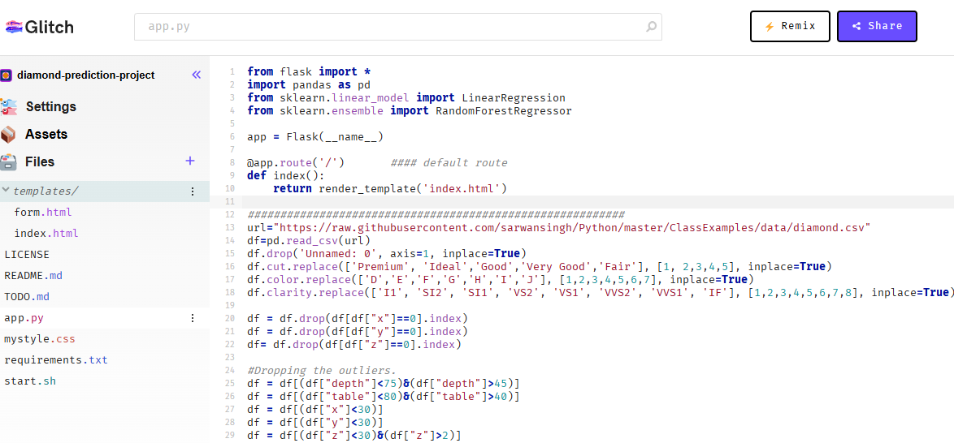

## Interface:

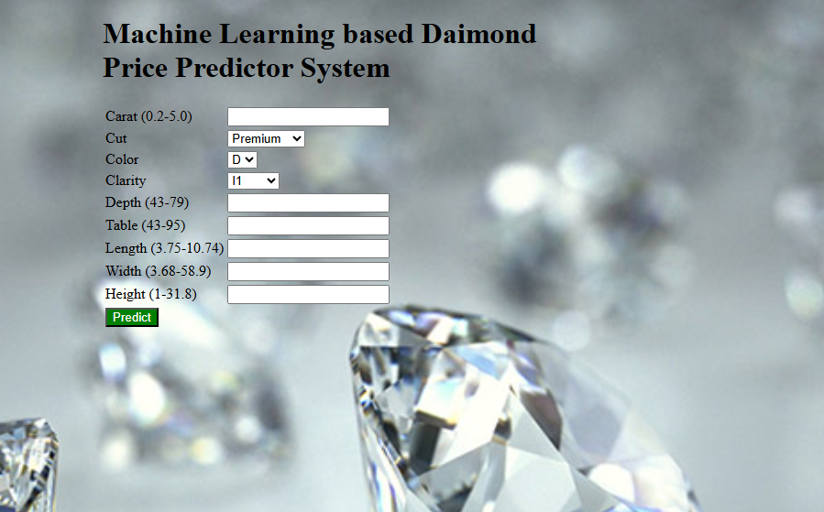

## Glitch Link: [AIML Predictor Project (diamond-prediction-project.glitch.me)](https://diamond-prediction-project.glitch.me/)